NAME = SHOBHIT VERMA

Q 1 wap to demonstrate ternary operator .define a variable marks  .ask its value from user and using ternary operator check if marks > 40 store "Pass" in result varible else store "Fail"

**package** assignment1day2;

**import** java.util.*;

**public** **class** Q1 {

**public** **static** **void** main(String[] args) {

Scanner sc=**new** Scanner(System.***in***);

System.***out***.println("enter mark");

**int** mark=sc.nextInt();

String result = (mark > 40) ? "pass" : "fail" ;

System.***out***.println("your mark is "+mark+" and you are "+result+" in exam");

}

}

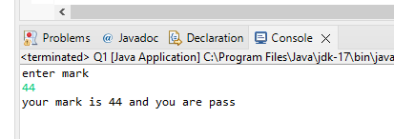

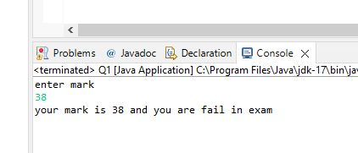

Q 2 using ternary check if number entered by user is positive or negative .  
In case number is positive store "Positive number" else store negative number to Result variable

**package** assignment1day2;

**import** java.util.Scanner;

**public** **class** Q2 {

**public** **static** **void** main(String[] args){

Scanner sc=**new** Scanner(System.***in***);

System.***out***.println("enter number");

**int** number=sc.nextInt();

String result = (number >= 0) ? "positive" : "nagative" ;

System.***out***.println("your number is "+number+" and the number is "+result);

}

}

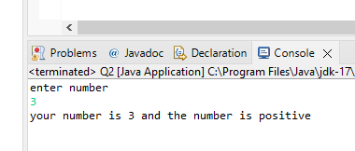

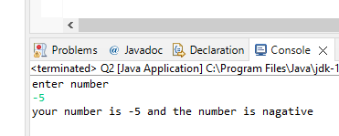

Q 3 WAP to ask name ,age and salary of an employee and print on console.

**package** assignment1day2;

**import** java.util.*;

**public** **class** Q3 {

**public** **static** **void** main(String[] args) {

Scanner sc= **new** Scanner(System.***in***);

System.***out***.println("enter your name");

String name = sc.nextLine();

System.***out***.println("enter your age");

**int** age = sc.nextInt();

System.***out***.println("enter your salary");

**int** salary = sc.nextInt();

System.***out***.println("Input name is "+name);

System.***out***.println("Input age is "+age);

System.***out***.println("Input salary is "+salary);

}

}

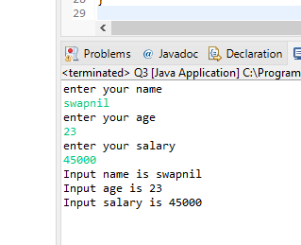

Q 4 wap  that ask two numbers from user and print greater number among two

**package** assignment1day2;

**import** java.util.*;

**public** **class** Q4 {

**public** **static** **void** main(String[] args) {

Scanner sc = **new** Scanner(System.***in***);

System.***out***.println("enter 1st number");

**int** no1=sc.nextInt();

System.***out***.println("enter 2nd number");

**int** no2=sc.nextInt();

**if**(no1>no2) {

System.***out***.println(no1+" is grater then "+no2);

}

**else** **if**(no1<no2){

System.***out***.println(no2+" is grater then "+no1);

}

**else** {

System.***out***.println(no1+" and "+no2+" are equal");

}

}

}

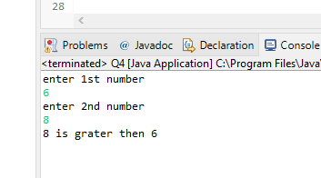

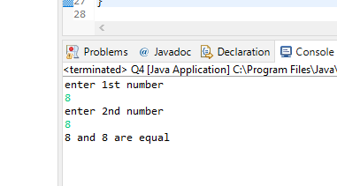

Q 5 wap to ask product name and price of product from user and calculate discount i.e   
if price > 2000 then discount is 10 percent of price   
else   
discount is 7 % of price

**package** assignment1day2;

**import** java.util.*;

**public** **class** Q5 {

**public** **static** **void** main(String[] args) {

Scanner sc = **new** Scanner(System.***in***);

System.***out***.println("enter product name");

String product =sc.nextLine();

System.***out***.println("enter product price");

**int** price =sc.nextInt();

**if**(price>2000) {

System.***out***.println(" you will get 10% discount");

}

**else** {

System.***out***.println(" you will get 7% discount");

}

**double** discount;

**if**(price>2000) {

discount=price*0.1;

}

**else** {

discount=price*0.07;

}

**double** discount_is = price - discount;

System.***out***.println("Product: " + product);

System.***out***.println("Price: " + price);

System.***out***.println("Discount: " + discount);

System.***out***.println("Discounted price: " + discount_is);

}

}

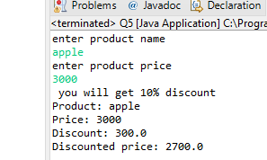 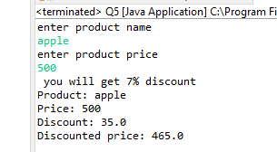

Q 6   Wap to swap two numbers

**package** assignment1day2;

**import** java.util.*;

**public** **class** Q6 {

**public** **static** **void** main(String[] args) {

Scanner sc =**new** Scanner(System.***in***);

System.***out***.println("enter randam two no");

**int** no1 =sc.nextInt();

**int** no2 =sc.nextInt();

System.***out***.println("before swaping two number no 1 is "+no1+" and no 2 is "+no2+" is");

no1=no1+no2;

no2=no1-no2;

no1=no1-no2;

System.***out***.println("after swaping two number no 1 is "+no1+" and no 2 is "+no2+" is");

}

}

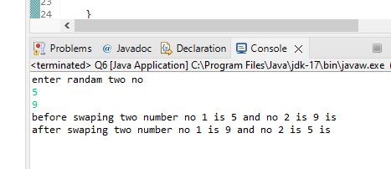

Q 8 wap to check is number is even or odd.

**package** assignment1day2;

**import** java.util.*;

**public** **class** Q8 {

**public** **static** **void** main(String[] args) {

Scanner sc=**new** Scanner(System.***in***);

System.***out***.println("enter number for check even or odd");

**int** number=sc.nextInt();

**if**(number%2==0) {

System.***out***.println(number+" is even number");

}

**else** {

System.***out***.println(number+" is odd number");

}

}

}

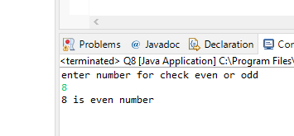

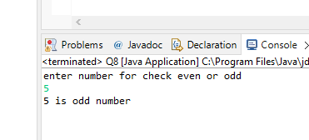

Q 9   A school has following rules for grading system:  
 a. Below 25 - F  
 b. 25 to 45 - E  
 c. 45 to 50 - D  
 d. 50 to 60 - C  
 e. 60 to 80 - B  
 f. Above 80 - A  
 Ask user to enter marks and print the corresponding grade

**package** assignment1day2;

**import** java.util.*;

**public** **class** Q9 {

**public** **static** **void** main(String[] args) {

Scanner sc=**new** Scanner(System.***in***);

System.***out***.println("enter your mark");

**int** mark=sc.nextInt();

**if**(mark<100) {

**if**(mark<25) {

System.***out***.println("F");

}

**else** **if**(mark>=26&&mark<=45) {

System.***out***.println("E");

}

**else** **if**(mark>=46&&mark<=50) {

System.***out***.println("D");

}

**else** **if**(mark>=51&&mark<=60) {

System.***out***.println("C");

}

**else** **if**(mark>=61&&mark<=80) {

System.***out***.println("B");

}

**else** **if**(mark>=81) {

System.***out***.println("A");

}

}

**else** {

System.***out***.println("invalid mark");

}

}

}

Case1

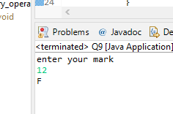

Case2

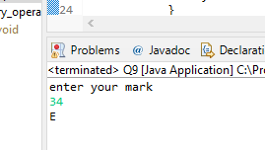

Case3

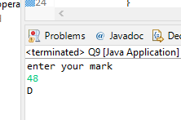

Case4

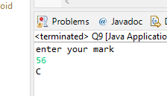

Case5

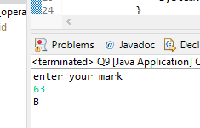

Case6

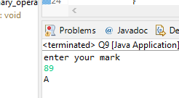

Case7

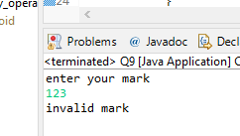

Q  10 wap to check greater number among three numbers

**package** assignment1day2;

**import** java.util.*;

**public** **class** Q10 {

**public** **static** **void** main(String[] args) {

Scanner sc= **new** Scanner(System.***in***);

System.***out***.println("enter 3 random number");

**int** a=sc.nextInt();

**int** b=sc.nextInt();

**int** c=sc.nextInt();

**int** max=(a>b)?(a>c?a:c):(b>c?a:c);

System.***out***.println("max number is "+max);

}

}

